Call Out for New Trustees and Board Directors for Arts, Culture & Heritage Organisations

Do you have ideas on how the arts could be for everyone?
Would you like to get involved in making change happen?

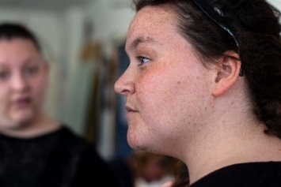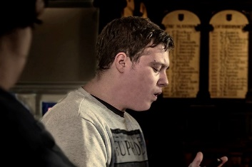

Background
Across Dorset 75% of Trustees and Board Directors are male, white and over 50 years. This means most of the population are not represented.
We want to help change this so that more people are represented and influence organisations, as trustees and directors.
We’re going to run a training programme for both Boards and 10-12 people interested in becoming a Trustee or Board Director for an organisation.

What is a Trustee or Board Director?
Trustees and Directors are the people who lead the charity or organisation and decide how it is run. Being a Trustee or Board Director means making decisions that will impact on people’s lives. Depending on what the organisation does, you will be making a difference to your local community.

How much time and money are involved?
There is no cost for this training.
The role of Trustee is voluntary.
Boards will pay for any trainee costs (eg child care, travel, support costs)
It is expected the time required to do this works out at 2-3 hours per month.
Trainees will work in pairs. You will have a personal mentor and a guide from within the organisation to help understand the process and make sure your voice is heard.

What does a New Trustee or Board Director have to do?
- Commit to learning new skills and leadership development over nine months
- Attend and participate in up to 5 group trainee training sessions, to learn new skills, understand roles and responsibilities and what it means to be a Trustee or Board Director, how to make your voice heard and share your expertise
- Attend x3 Board meetings
- Liaise with The Arts Development Company mentor Rosie Russell before and after each Board meeting
- Maintain a journal of your learning to share in any form that suits you
What’s the benefit to you?
- You will be part of a supportive network with your own personal mentor
- You will learn new skills
- It’s great to put on your CV
- You will be making a difference

What’s the timescale? June 2019 – March 2020
Interested? Please complete and send the questions below, plus a 2 minute phone-camera video about who you are and why you would like to be part of this programme to: rosie@theartsdevelopmentcompany.org.uk by 31 May.
Or phone Rosie on 01305 225636 for an informal chat to find out more.
Trainee Trustees’ Group 2019

Full Name:
Address and Postcode:
Email:
Contact number:
Gender:
Date of birth:
Ethnicity:
Do you regard yourself as differently able?
Please tell us if you have specific needs:

Why would you like to participate in this programme?

What’s been your biggest achievement this year?

Once completed please email to rosie@theartsdevelopmentcompany.org.uk
